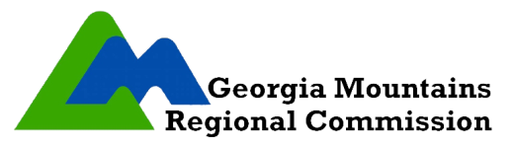

Local Elected Officials (LEO)
Board Meeting Notice

TO: WorkSource Georgia Mountains
Local Elected Officials
FROM: Greg James, Chief Local Elected Official
DATE: October 3, 2022

The WorkSource Georgia Mountains, Local Elected Officials (LEO) Board, will hold its regular yearly meeting on Thursday, October 27, 2022 at 3:00 p.m.
The meeting will be held at the Lumpkin County Library located at 56 Mechanicsville Rd., Dahlonega, GA 30533.
Please RSVP by contacting Gina Kessler at gkessler@gmrc.ga.gov or call 770-538-2607.

